Security Radar
V2.810.0000001.0
Release Notes
ZHEJIANG DAHUA VISION TECHNOLOGY CO., LTD.

Legal Information

Copyright
© 2020 ZHEJIANG DAHUA VISION TECHNOLOGY CO., LTD. All rights reserved.
This document cannot be copied, transferred, distributed, or saved in any form without the prior written permission of Zhejiang Dahua Vision Technology Co., LTD (hereinafter referred to as "Dahua").
The products described in this document may contain the software that belongs to Dahua or the third party. Without the prior written approval of the corresponding party, any person cannot (including but not limited to) copy, distribute, amend, abstract, reverse compile, decode, reverse engineer, rent, transfer, sublicense the software.
Trademarks
, , , and are the trademarks or registered trademarks of Dahua.
All other company names and trademarks mentioned herein are the properties of their respective owners.
Disclaimer
- These release notes are for reference only, and the actual product shall prevail.
- Succeeding products and release notes are subject to change without notice.
- If there is any uncertainty or controversy, please refer to our final explanation.
Table of Contents

Legal Information I
Release Notes 1
1 Overview 1
2 Functions and Application 1
3 New Features 2
4 Fixed Bugs 2
5 Compatibility 2
6 Matching Information 2
7 Pending Issues 3
8 Update Guide 3

Release Notes

Overview
Item | Description
Product Name | Security Radar
Version | Radar: V2.810.0000001.0.R.200326  MCU: General_PFR4K-D_V1.000.0000000.2.R.200107 General_PFR4K-E_V1.000.0000000.2.R.200107.zip
Software Package Information | Radar Program: DH_SD-Prometheus_MultiLang_PN_Stream3-Radar_ V2.810.0000001.0.R.200326.zip  DH_SD-Prometheus_MultiLang_NP_Stream3-Radar_ V2.810.0000001.0.R.200326.zip  MCU Program: General_PFR4K-D_V1.000.0000000.2.R.200107.zip  General_PFR4K-E_V1.000.0000000.2.R.200107.zip
OS Requirement | None
Release Date | April 15, 2020

Functions and Application
This security radar is mainly used in outdoor moving targets detection to output target trajectory and related information. Radar detection has extremely high accuracy, and is not affected by factors such as weather and light. It can be effectively applied to various perimeter and region protection scenarios.
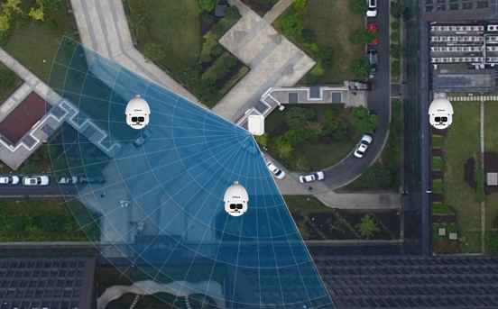
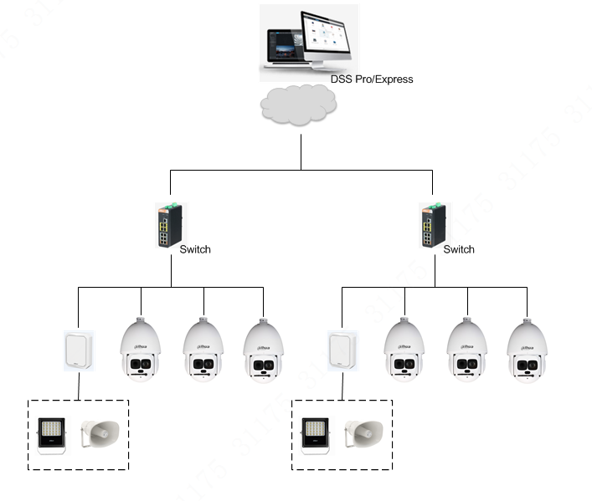

New Features
No. | Version | Release time
1 | V2.800.0000009.1.R.200303 | 2020-3-13
2 | V2.810.0000001.0.R.200326 | 2020-4-15

Fixed Bugs
No. | Bugs
1 | Repair the Speed Domes track the same target in turn when choose the Tour mode.
2 | Repair the Speed Domes track the targets in the alarm area and the pre-warning area in turn.
3 | Optimize the function of scene change
4 | Add display of radar algorithm version
5 | Remove the linkage setting for the shielded area
6 | Fixed the failure to set the boot time

Compatibility
/

Matching Information
Radar+PTZ smart tracking, and the speed dome models are as follows:

SD Series | Model
SD49 | DH-SD49225/49412/49212T-HN-S2
 | DH-SD49425XB-HNR
 | DH-SD49225XA-HNR
SD59 | DH-SD59430/59230/59225U-HNI
 | DH-SD59232/432/425XA-HNR
SD5A | DH-SD5A425/445XA-HNR
SD6CE | DH-SD6CE245/230/225U-HNI
 | DH-SD6CE445XA-HNR
SD60 | DH-SD60430/230/225U-HNI
SD65F | DH-SD65F233XA-HNR
SD6AL | DH-SD6AL245U-HNI(IR)
 | DH-SD6AL233/445XA-HNR(IR)
SD6AE | DH-SD6AE233XA-HNI
 | DH-SD6AE240V-HNI
SD8A | DH-SD8A840/440/240/820WA-HNF
 | DH-SD8A840/440/240VI-HNI
DH-SD10 | DH-SD10A248V-HN
 | DH-SD10A248WA-HNF
PTZ | DH-PTZ83840-HNF-WA
 | DH-PTZ19245U-IRB-N(-B)
 | DH-PTZ19240V-IRB-N(-B)
 | DH-PTZ1A225U-IRA-N

Pending Issues
No. | Issue description | Possible result | How to fix
1 | Target filtering in the defined region is invalid. | Humans and vehicles cannot be filtered in the regions. | Upgrade the program version.
2 | When there are electronic devices with the same frequency band in the radar detection range, false alarms might occur. | The alarm needs to be checked manually. | Make sure that no device with the same frequency band (24.05–24.25 GHz) is in the detection range.
3 | When the wind is strong, false alarms might occur from trees. | The alarm needs to be checked manually. | Draw a shield area to shield those trees.
4 | The shield area will not be active whent it is drawn beyond the protected area. | The shield area will not be active. | Redraw the shielded area within the protected area.

Update Guide
Refer to the Radar Update Guide.

ZHEJIANG DAHUA VISION TECHNOLOGY CO., LTD.
Address: No.1199, Bin'an Road, Binjiang District, Hangzhou, P.R. China
Postcode: 310053
Tel: +86-571-87688883
Fax: +86-571-87688815
Email: overseas@dahuatech.com
Website: www.dahuasecurity.com

