NVR4XXX-4KS2_V4.000.0000000.1
Release Notes
ZHEJIANG DAHUA VISION TECHNOLOGY CO., LTD.

Legal Information

Copyright
© 2019 ZHEJIANG DAHUA VISION TECHNOLOGY CO., LTD. All rights reserved.
This document cannot be copied, transferred, distributed, or saved in any form without the prior written permission of Zhejiang Dahua Vision Technology Co., LTD (hereinafter referred to as "Dahua").
The products described in this document may contain the software that belongs to Dahua or the third party. Without the prior written approval of the corresponding party, any person cannot (including but not limited to) copy, distribute, amend, abstract, reverse compile, decode, reverse engineer, rent, transfer, sublicense the software.
Trademarks
, , , and are the trademarks or registered trademarks of Dahua.
All other company names and trademarks mentioned herein are the properties of their respective owners.
Disclaimer
- These release notes are for reference only, and the actual product shall prevail.
- Succeeding products and release notes are subject to change without notice.
- If there is any uncertainty or controversy, please refer to our final explanation.
Table of Contents

Legal Information I
Release Notes 1
1.1 Overview 1
1.2 New Features 1
1.3 Fixed Bugs 4
1.4 Instructions for New Features 4
1.4.1. New NVR 4.0 UI 4
1.4.2. Web browser display normally without plug-in 7
1.4.3. HDD Health Detection 7
1.4.4. Dual-sensor People Counting 9
1.4.5. Internationalization 11
1.4.6. Switching to H.265 Automatically 12
1.4.7. Thermal Imaging Camera 12
1.4.8. Panoramic + PTZ Network Camera 13
1.4.9. AI Fisheye Camera 16
1.5 Compatibility 18
1.6 Software Environment 19
1.7 Pending Issues 24
1.8 Update Guide 24

Release Notes

Overview
Item | Description
Product model | NVR4XXX-4KS2 Series
Version | V4.000.0000000.1,
Software package information | DH_NVR4XXX-4KS2_MulitLang_V4.000.0000000.1.R.20190809.zip
Onvif Version | 2.4.1
OS requirement | None
Release date | 8/16/2019

New Features
Function name | Functional Description
NVR4.0 new UI | - It is to realize NVR interface based on the 4.0 interface style. The same functions are basically the same, and the market requires to retain the existing functions of the NVR.  - Adjust the main menu. AI setting and AI search are put together with a separate AI menu items, other events are in the alarm item, and the main and auxiliary screens are set to the right-click menu.  - Supports vector font.  - Web interface style is consistent with the local menu.
Network Security Baseline V2.0 | - Supports system firmware encryption.  - The device supports 802.1x access authentication.  - TFTP upgrade: The trusted upgrade and secure boot by Uboot.  - Supports network security requirements such as firewall.
Support web no plugin | - Version requirements: For chrome version number lower than 42, Firefox version lower than 52, there is a plug-in. For the browser higher than the above versions, there is no plug-in.  - Supported contents are mainly based on video.
ONVIF optimization | - Supports ONVIF18.06 tool.  - Supports profile G.
International requirements | - Adds Shut down button before initialization.  - Adds the country, language, and format settings.  - Supports synchronizing audio, format, and time zone to the front-end device when connecting to it.
Automatic H265 | - Automatic setting front-end adopts H.265 encoding when registering remote device to the NVR.
Email optimization | - Adds IPC channel name in the body contents of the alarm email.  - Standardizes intelligent event email format.
Auto registration | - The whole series supports the auto registration function suitable to connect to all platforms.  - Auto registration through domain name.
Alarm Center Dual IP | - Supports server of dual-IP.  - Supports to upload alarm information to 2 server addresses at the same time.
Hard disk health plan | - Supports hard disk health detection.  - Supports manual detection refresh.  - Supports to display detection details report.  - Supports alarm prompt for detected errors. Right now it supports hard disk temperature too high, linkage abnormality, imminent error, vibration, etc.
Raid optimization | - On RAID interface, cut disk array enclosure item. (it was never supported before)  - Raid creation and deletion process are in the background.  - Adds the working mode of the raid hard disk.
Hard disk estimation | - Adds hard disk estimation function.  - Supports the hard disk storage capacity estimation based on the resolution stream of the current access channel.
Hard disk migration | - Hard disk migration formatting strategy, adding "unformatted" status.
FTP experience optimization | - Supports FTP storage pictures based on channels.
Hard disk light | - When the hard disk is abnormal, the indicator light is on. When it is normal, the indicator light is off.  - The HDD abnormal event does not affect hard disk light.
Intelligent Speed Dome | - Unified Intelligent IPC and smart speed dome protocol.  - Supports smart speed dome IVS.  - Supports smart speed dome people counting.  - Supports smart speed dome heat map.  - Supports smart speed dome metadata.
AI by camera image matting | - Once the connected channel has no matting image, the NVR can realize image matting based on the coordination.  - Supports image matting in preview mode.  - For smart types such as perimeter protection and license plates, supports image matting in preview mode.  - Right now, does not support image matting storage.  - Supports detected plate image matting during playback.
AI Linkage snapshot | - For AI event, there is picture storage function instead of snapshot.  - For AI events, the back-end analytics realizes the image matting and the large image and matting image will be sent with the event when the client subscribes.  - Cannot configure to trigger other channels.
National information code | - ITC reports a 3-digit code table. The NVR currently only maintains a 2-bit table. The NVR needs to maintain 2-bit and 3-digit codes.
Binocular passenger flow statistics | - Fixed bug: Supports regional people counting.  - Support configuration and report search.
Password resetting | - Adjust reserved mailbox item: From the admin user configuration interface to Reset Password page of the security center.  - At the same time, security question and reserved mailbox item are merged onto the Reset Password interface.
Recover password | - Adjust the QR code of the device's local GUI, and the QR marks as local GUI.  - For the storage device, user can only scan the local QR code to reset password. Delete scanning QR code on Web to reset password. Do not support resetting password by Configtool. Supports resetting password by DMSS.  - Log: password reset operation log type is security management.
MAC address binding | - Supports setting the MAC address for newly added users, and only allows access to users through specific MAC devices.

Fixed Bugs
The fixed bugs are included in the chapter 1.2 New Features.

Instructions for New Features

New NVR 4.0 UI
    - Interface Style
The new UI uses flat design which is more consistent with users’ habits. It’s divided into configuration area, function area, fast operation area and page turning area. You can turn pages to display more functions supported by the device.
              - New UI (1)
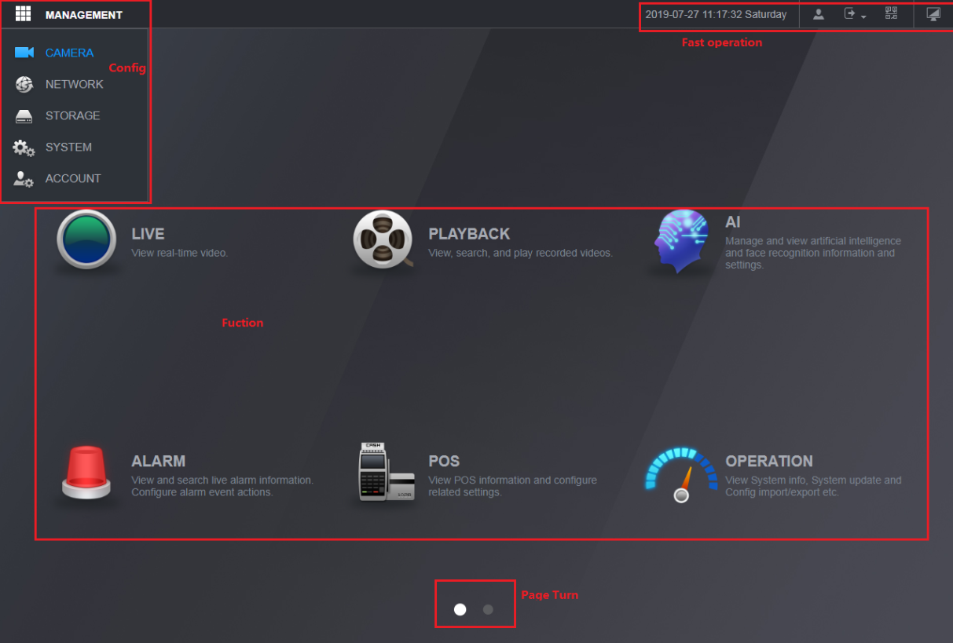
              - New UI (2)
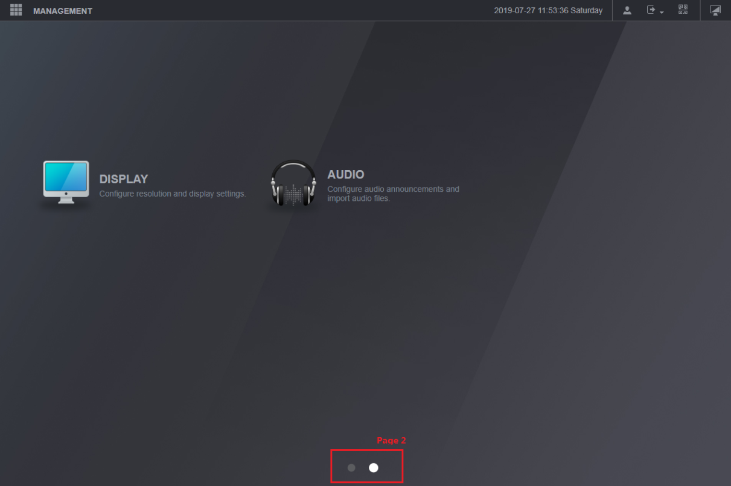
    - Interface Display
The interfaces of local configuration and Web are almost identical. There are slight differences in operating on two interfaces.
              - Difference between two interfaces
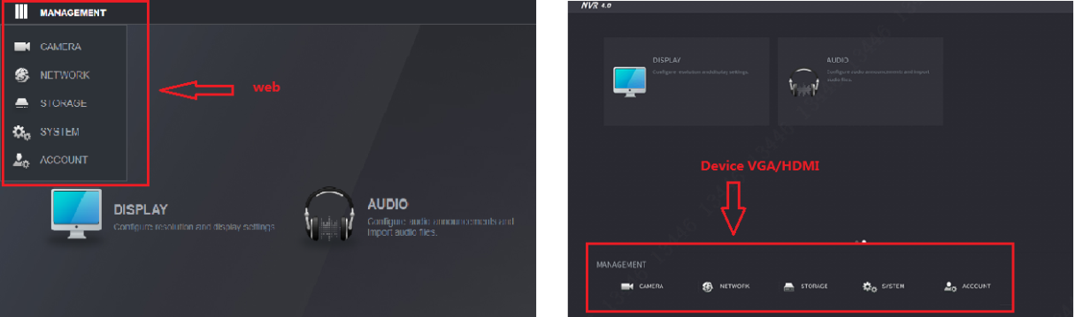
    - Menu Integration
Related functions are centralized and categorized.
- All AI related functions are concentrated on AI interface: Including AI query, AI configuration, AI database and so on.
              - AI interface
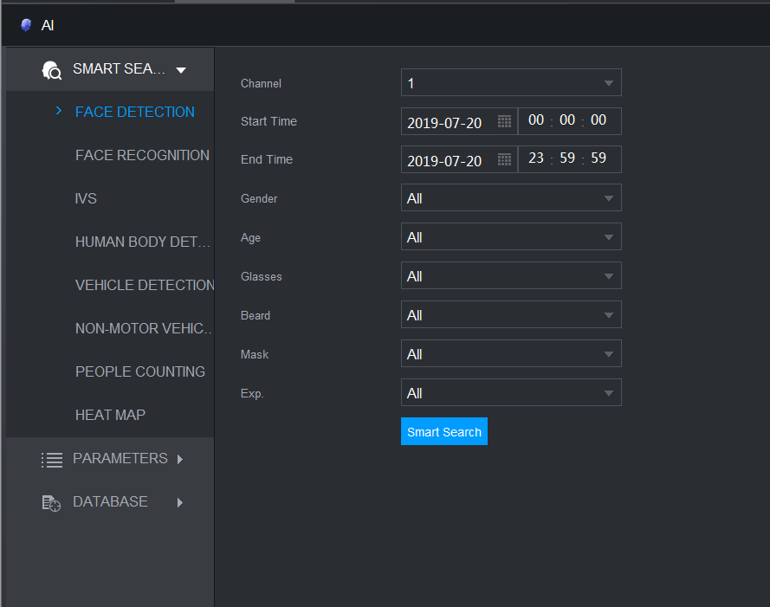
- Logs are classified on the basis of functions. Event logs are centralized in Alarm interface and system logs are centralized in Operation interface.
              - Alarm
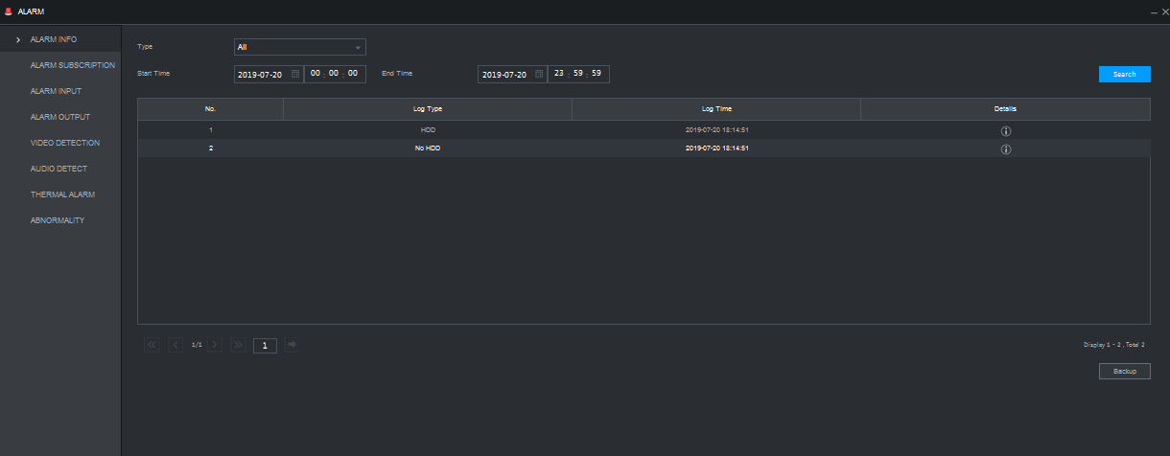
              - Operation
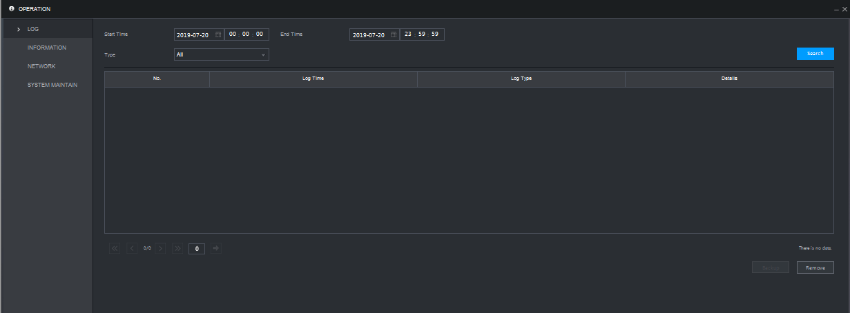

Plug-in Free Version of Web Browsers
- Versions of web browsers
Web Browser | Plug-in version | Plug-in free version
Chrome | Version number < 42 | Version number >= 42
Firefox | Version number < 52 | Version number >= 52
Internet Explorer | All Versions | /
Edge | / | All Versions

- Differences between plug-in version and plug-in free version
Difference | Plug-in version of web browser | Plug-in free version of web browser
Channel navigation bar button | Included. | Not included.
Video overlay text | Included. | Not included.
Install plug-in to view channel video | Included. | Not included.

- Functions supported by plug-in free version
Function | Description
Surveillance screen | Real-time surveillance（main stream, sub stream）
 | Full screen
 | Window split
Playback | Video playback
 | Full screen playback
 | Time bar
 | Record query
Remote device | Importing and exporting of remote devices
Configuration | Camera
 | OSD overlay
 | POS setup - POS position setting
 | Motion detection area setting

HDD Health Detection
- HDD Health Detection
Supports displaying HDD health status of Seagate SKYHAWK series.
- HDDs are listed on the interface with information such as HDD space, manufacturer, serial number and health status.
- HDD health status: Normal (normal font), Warning (orange font), Unnormal (red font). Reasons for warnings and errors are displayed in Health status column.
- When a 20X error occurs, Bad Soon will be displayed in Health status column.
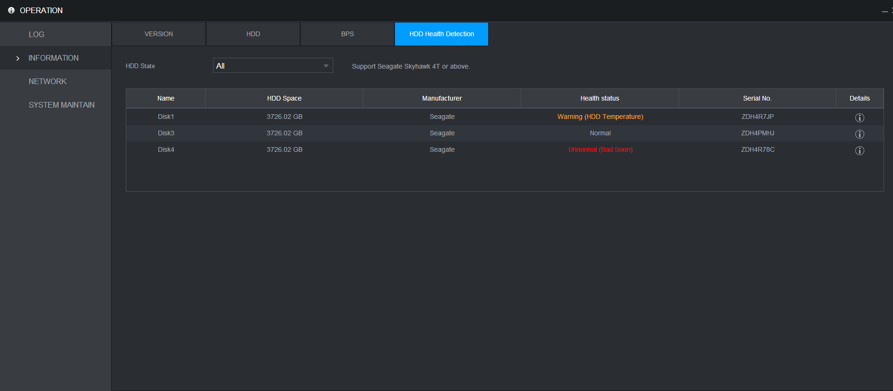
- Refreshing Health Status Manually
Click Manual Detect at the lower-left corner of the interface to refresh health status detection.
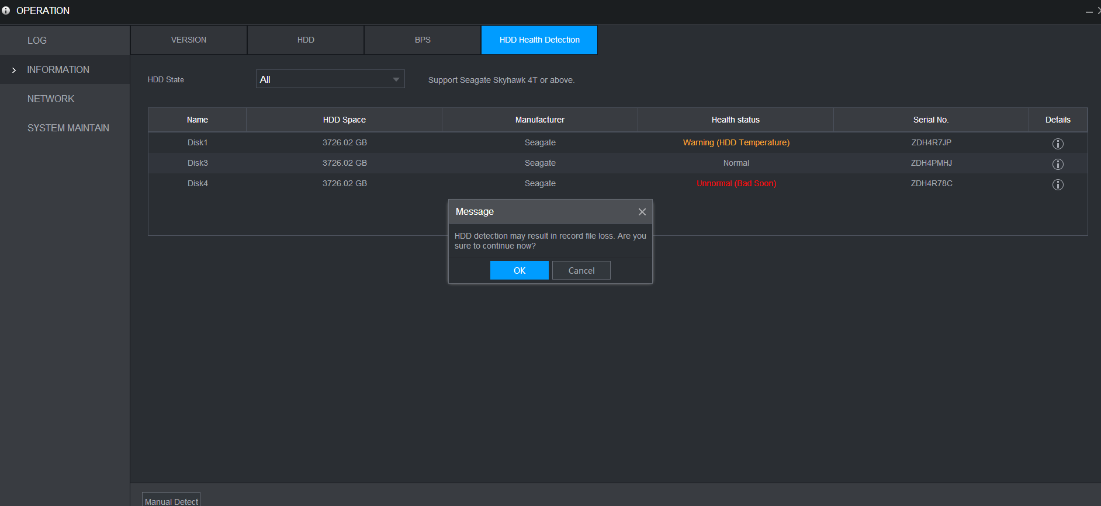
- Disk Details
- Double-click a HDD in the list to show detection diagram.
- In the details dialog box, you can find a table with Detect Type and Recently Detected Value. Select a row to show details of the corresponding parameter in a line chart below. You can click Recent One Week, Recent One Month or define a time frame (at most 1 year) to get details of the parameter in a specified period. The default period of time is one week.
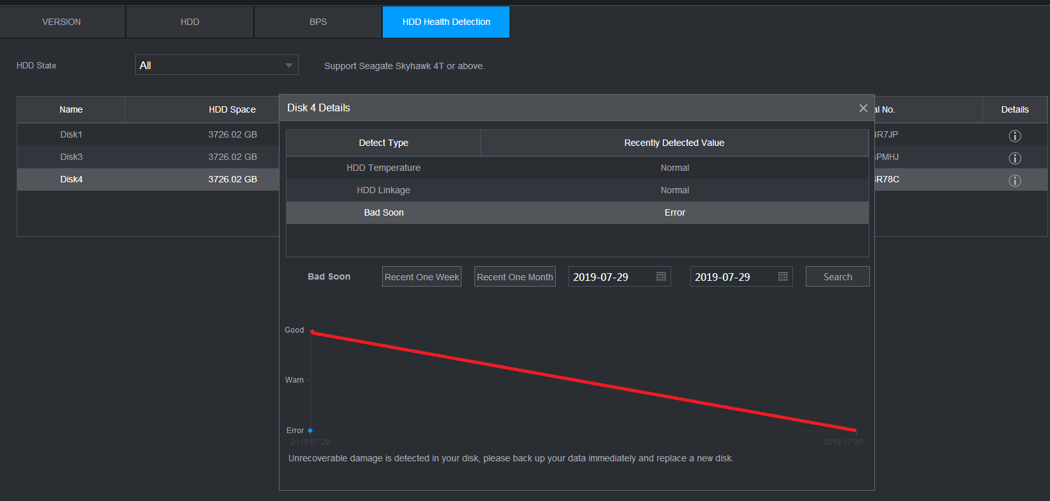

Dual-sensor People Counting
- Configuring Parameters and Counting People
Enter the PEOPLE COUNTING interface to count the number of people in a detection area, and configure parameters such as rule, number of people, enable, detection area, alarm and so on.
- Currently, rule setting for only one area is supported.
- You can draw a random area to set rules, and define a rule name.
- The number of people of a rule will be displayed at the up-left corner of the video.
              - Configure parameters
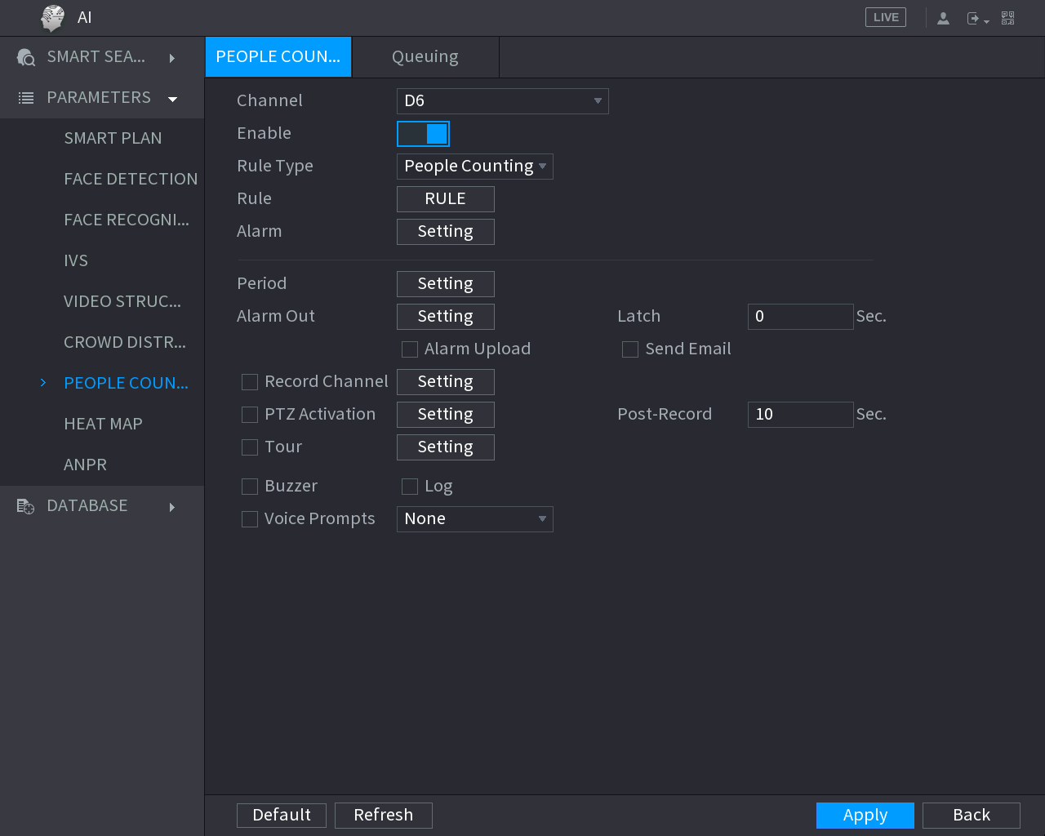
              - People counting
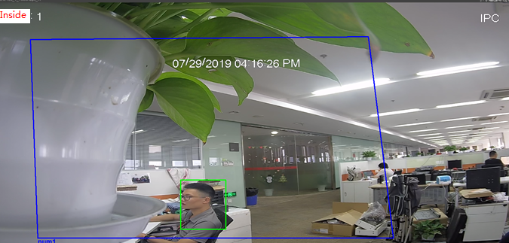
- Report Query
On the upper-half interface, you can select channel number, rule, start time and end time, stay time and so on. Report type includes people counting report and stay time report, and both of them can be displayed in histogram and line chart.
- The horizontal axis of people counting report shows the time line and the vertical axis shows the number of people. The number of people and stay time can be chosen to be displayed in people counting report.
- The horizontal axis of stay time shows the time line and the vertical axis shows stay time. You can select to show the number of people and their stay time in the detection area.
              - People counting report
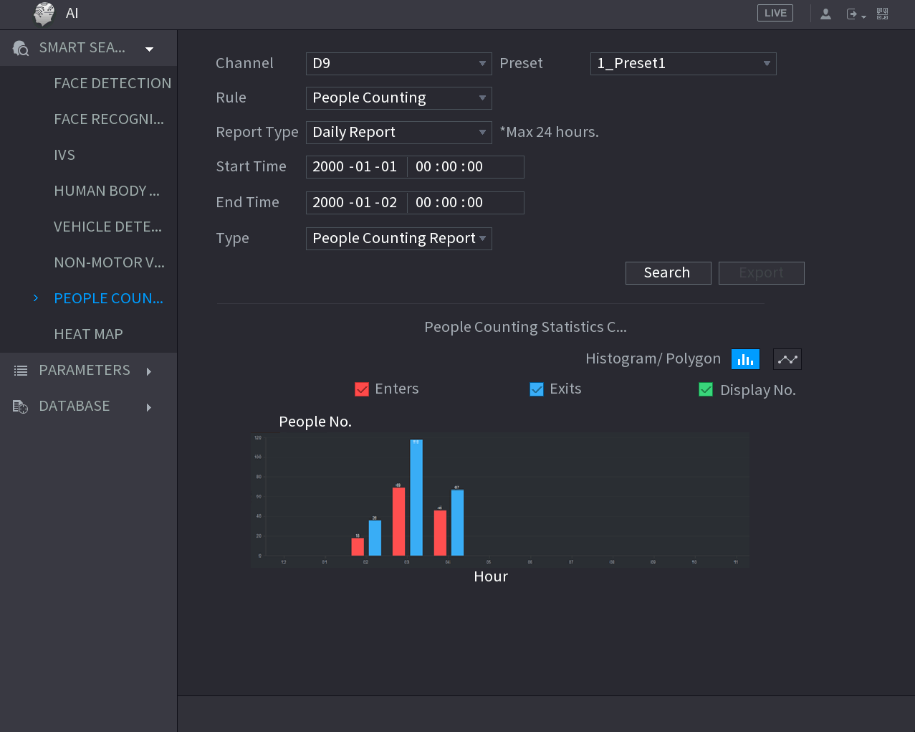

Internationalization
Internationalization means that you can select location during the initialization of a device, and language and video standard will be matched automatically. Configurations such as language, video standard and system zone will be synchronized when connecting to front-end. The access to local GUI configuration is as follows:
- The device initialization process will start at the first boot, and you can select Location and Video Standard on the following interface.
              - Device initialization (1)
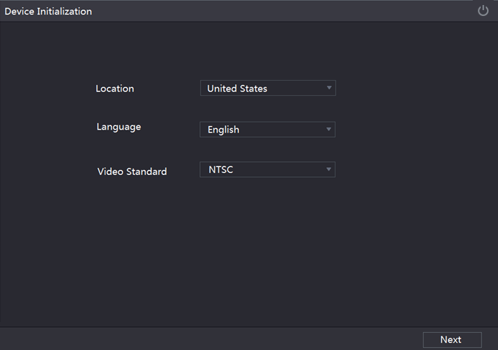
- Select System Zone and System Time on the following interface.
              - Device initialization (2)
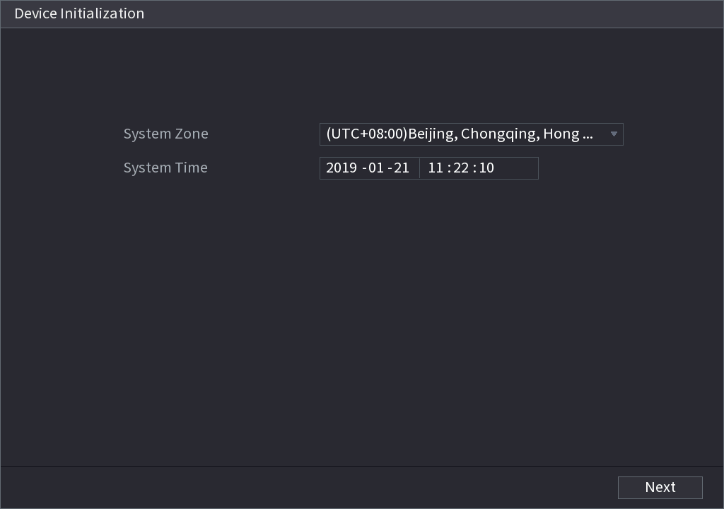

Switching to H.265 Automatically
After H.265 Auto Switch is enabled, remote devices supporting H.265 will be adjusted to H.265 encoding format automatically. You can enable H.265 Auto Switch on the following local GUI interface.
              - Registration
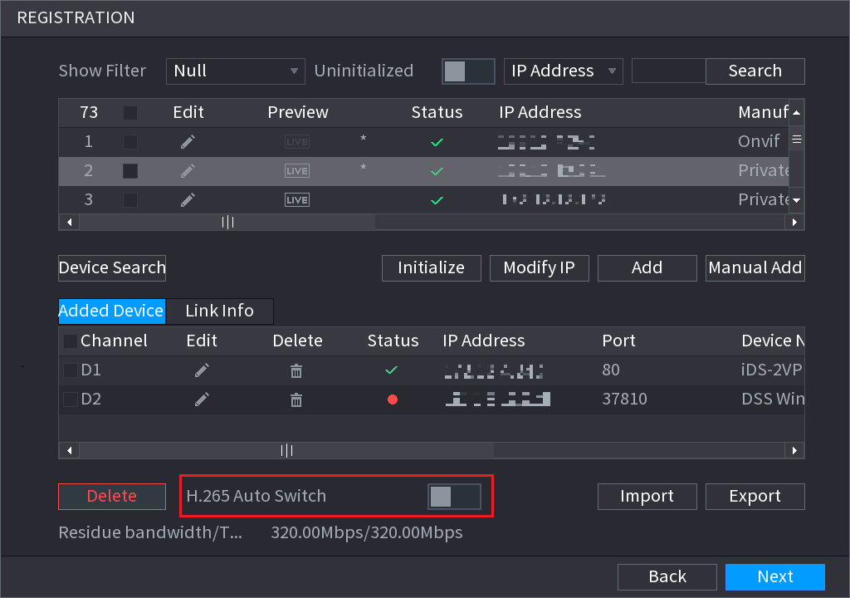

Compatibility
After updating to latest new baseline version 4.0, user cannot update back to versions lower than version 4.0

Software Environment
Model | Version
DH-IPC-HFW81230E-Z-IRA, | 2.6.01.05.06362  DH_IPC-HX8XXX-Nova_Chn_PN_Stream3_V2.640.0000004.0.R.190118.zip
DH-IPC-HF8331FP-S2, | 2.6.01.05.06365  DH_IPC-HX8XXX-Nova_MultiLang_PN_Stream3_V2.640.0000004.0.R.190118.zip
DH-IPC-HF81239F, | 2.6.01.05.06889  DH_IPC-HX8XXX-Wei-Nova2_Chn_PN_Stream3_V2.622.0000000.6.R.190130.zip
DH-IPC-HFW5233F-ZSA-27135, | 2.6.01.05.05914  DH_IPC-HX4XXX-Eos_Chn_PN_Stream3_V2.680.0000000.41.R.181212.zip
DH-IPC-HFW8239K-Z-I4-3512, | 2.6.01.05.05912  DH_IPC-HX8XXX-Eos_Chn_PN_Stream3_V2.680.0000000.41.R.181212.zip
DH-IPC-HFW8438K-Z-I4-27135, | 2.6.01.05.03379  DH_IPC-HX5X3X-Rhea_Chn_PN_Stream3_V2.622.0000000.30.R.180905.zip
DH-IPC-HFW4443M-AS-PV-I2-0360B, | 2.6.01.05.08342  DH_IPC-HX5XXX-Volt_Chn_PN_Stream3_V2.680.0000000.5.R.190404.zip
DH-IPC-HFW4833F-ZAS-3512, | 2.6.01.05.08213  DH_IPC-HX5(4)XXX-Sag_Chn_PN_Stream3_V2.800.0000000.2.R.190404.zip
DH-IPC-HFW4433K-AS-I4-0360B, | 2.6.01.05.05914  DH_IPC-HX4XXX-Eos_Chn_PN_Stream3_V2.680.0000000.41.R.181212.zip
DH-IPC-HDBW5233E-Z-X1-27135-DC12AC24V, | 2.6.01.05.07673  DH_IPC-HX5X3X-Rhea_Chn_PN_Stream3_V2.800.0000005.0.R.190325.zip
DH-IPC-HFW4631K-AS-I4-0360B, | 2.6.01.05.07673  DH_IPC-HX5X3X-Rhea_Chn_PN_Stream3_V2.800.0000005.0.R.190325.zip
DH-IPC-HFW5433E-Z-IRA-X1-0560-DC12AC24V, | 2.6.01.05.07673  DH_IPC-HX5X3X-Rhea_Chn_PN_Stream3_V2.800.0000005.0.R.190325.zip
DH-IPC-HFW5631E-Z-0735-AC24V, | 2.6.01.05.07673  DH_IPC-HX5X3X-Rhea_Chn_PN_Stream3_V2.800.0000005.0.R.190325.zip
DH-IPC-HDBW5431EP-ZE-27135, | 2.6.01.05.07655  DH_IPC-HX5X3X-Rhea_MultiLang_PN_Stream3_V2.800.0000005.0.R.190325.zip
DH-IPC-HDBW5831EP-ZE-0735, | 2.6.01.05.07655  DH_IPC-HX5X3X-Rhea_MultiLang_PN_Stream3_V2.800.0000005.0.R.190325.zip
DH-IPC-HUM8231P-E2, | 2.6.01.05.02685  DH_IPC-HX5X3X-Multi-Rhea_Eng_P_V2.622.0000000.31.R.180813.zip
DH-IPC-HUM7233-E1, | 2.6.01.05.07673  DH_IPC-HX5X3X-Rhea_Chn_PN_Stream3_V2.800.0000005.0.R.190325.zip
DH-IPC-HFW8249E-ZFR-IRA-LED-0832, | 2.6.01.05.07146  DH_IPC-HX8X4X-Warpway_Chn_PN_Stream3_V2.680.0000000.1.R.190223.zip
DH-IPC-HF8841F-FD, | 2.6.01.05.07146  DH_IPC-HX8X4X-Warpway_Chn_PN_Stream3_V2.680.0000000.1.R.190223.zip
DH-IPC-HFW8841E-ZFR-IRA-LED-67134, | 2.6.01.05.07146  DH_IPC-HX8X4X-Warpway_Chn_PN_Stream3_V2.680.0000000.1.R.190223.zip
DH-IPC-HFW8249E-ZFDI-IRA-LED-0832, | 2.6.01.05.07160  DH_IPC-HX8X4X-Warpway2_Chn_PN_Stream3_V2.680.0000000.1.R.190223.zip
DH-IPC-HDW7341X-E2-0280B, | 2.6.01.05.05281  DH_IPC-HX8X4X-Kronos_Chn_PN_Stream3_V2.622.0000000.5.R.181215.zip
DH-IPC-HFW7243K-ZPC-I4-0735, | DH_IPC-HX8X4X-Warpway2_Chn_PN_Stream3_V2.622.0000000.9.R.181119.zip
DH-IPC-HD4140X-E2-0210B, | 2.6.01.05.08217  DH_IPC-HX7XXX-Sag_Chn_PN_Stream3_V2.800.0000000.2.R.190404.zip
DH-IPC-HDW8341XP-3D-0280B, | 2.6.01.05.05284  DH_IPC-HX8X4X-Kronos_Eng_P_Stream3_V2.622.0000000.5.R.181215.zip
DH-IPC-HDW7341X-B-E2-0280B, | 2.6.01.05.02992  DH_IPC-HX8X4X-Kronos_Chn_PN_Stream3_V2.622.0000000.4.R.180816.zip
DH-IPC-HFW8449K-ZRL-LED-3512, | DH_IPC-HX8XXX-Volt_Chn_PN_Stream3_V2.680.0000000.5.R.190404.zip
DH-IPC-HFW5541EP-ZE-27135, | DH_IPC-HX5XXX-Volt_MultiLang_PN_Stream3_V2.680.0000000.5.R.190404.zip
DH-IPC-HFW5241EP-ZE-27135, | DH_IPC-HX5XXX-Volt_MultiLang_PN_Stream3_V2.680.0000000.5.R.190404.zip
DH-IPC-HFW5541EP-ZE-27135, | DH_IPC-HX5XXX-Volt_MultiLang_PN_Stream3_V2.680.0000000.5.R.190404.zip
DH-IPC-HF8242FP-FR, | 2.6.01.05.07153  DH_IPC-HX8X4X-Warpway_EngSpnFrn_PN_Stream3_V2.680.0000000.1.R.190223.zip
DH-IPC-HF8242FP-FD, | 2.6.01.05.07153  DH_IPC-HX8X4X-Warpway_EngSpnFrn_PN_Stream3_V2.680.0000000.1.R.190223.zip
DH-IPC-HF8241FP, | 2.6.01.05.07170  DH_IPC-HX8X4X-Warpway2_EngSpnFrn_PN_Stream3_V2.680.0000000.1.R.190223.zip
DH-IPC-PDBW5831P-B360-E4-2712, | 2.6.01.05.06704  DH_IPC-HX8(5)XXX-Sag_EngSpnFrn_PN_V2.622.0000000.21.R.190125.zip
DH-IPC-PDB4830P-B360-E4-0360B, | 2.6.01.05.07064  DH_IPC-HX8(5)XXX-Sag_EngSpnFrn_PN_V2.622.0000000.22.R.190225.zip
DH-PSDW5631SP-B360-E4-D204-DC12V, | 2.6.01.05.06035  DH_IPC-HX8(5)XXX-Sag_EngSpnFrn_PN_V2.622.0000000.20.R.190110.zip
DH-IPC-PFW8809-H-A180-E4-AC24V, | DH_IPC-PFW8XXX-Nova_Chn_PN_Stream3_V2.622.0000000.3.R.181201.zip
DH-PSDW81649-H-A360-E9, | DH_IPC-PSD8XXX-Fafnir_Chn_PN_Stream3_V2.622.0000000.1.R.181205.zip
DH-PSD81602P-H-A360-E9, | DH_IPC-PSD8XXX-Nova_Eng_P_Stream3_V2.460.0000.4.R.20170927.zip
DH-IPC-PFW8802P-H-A180-E4-AC24V, | DH_IPC-PFW8XXX-Nova_Eng_P_Stream3_V2.622.0000000.3.R.181201.zip
DH-IPC-HDBW4231FP-E2-M-0360B, | 2.6.01.05.02685  DH_IPC-HX5X3X-Multi-Rhea_Eng_P_V2.622.0000000.31.R.180813.zip
DH-IPC-EW5431-ASW, | 2.1.02.01.17602  DH_IPC-HX5X3X-Rhea_Chn_PN_Stream3_V2.460.0000000.16.R.20170919.zip
DH-IPC-EB5531, | 2.6.01.05.07655  DH_IPC-HX5X3X-Rhea_MultiLang_PN_Stream3_V2.800.0000005.0.R.190325.zip
DH-IPC-EBW81230, | 2.6.01.05.06903  DH_IPC-HX8XXX-Nova2_Chn_PN_Stream3_V2.622.0000000.6.R.190130.zip
DH-IPC-EBW8630P, | 2.6.01.05.06908  DH_IPC-HX8XXX-Nova2_EngSpnFrn_PN_Stream3_V2.622.0000000.6.R.190130.zip
DH-IPC-EBW81230P, | 2.6.01.05.06908  DH_IPC-HX8XXX-Nova2_EngSpnFrn_PN_Stream3_V2.622.0000000.6.R.190130.zip
ITC237-PU1B-IR, | 2.6.01.08.01701  General_ITC237-PU1B(PW1B)-IR(IRZ)(L)_Eng_PN_Oversea_Europe_V2.622.0000000.1.R.181114.zip
ITC237-PW1B-IRZ, | 2.6.01.08.01701  General_ITC237-PU1B(PW1B)-IR(IRZ)(L)_Eng_PN_Oversea_Europe_V2.622.0000000.1.R.181114.zip
ITC215-PW4I, | General_ITC215-PW4I-XXX_Eng_PN_Oversea_ITCPUSH_EuropeENTRANCE_V2.623.0000000.0.R.180930.zip
ITC952-RF2D, | General_ITCXX2-RF2D-IR_Eng_PN_Oversea_3G_V2.622.0000000.7.R.190321.zip
ITC352-RF2D, | General_ITCXX2-RF2D-IR_Eng_PN_Oversea_3G_V2.622.0000000.7.R.190321.zip
ITC302-RF2D, | General_ITCXX2-RF1D(RF2D)_Chn_P_V2.722.0000000.0.R.190409.zip
ITC902-RF2D, | General_ITCXX2-RF1D(RF2D)_Chn_P_V2.722.0000000.0.R.190409.zip
ITC235-RF1D, | General_ITC235-RF1D_Chn_P_V2.622.0000000.0.R.180424.zip
ITC235-RF2E, | General_ITC235-RF1E(RF2E)_Chn_P_Stream3_V2.620.0000000.0.R.180705.zip
ITC835-RF1D, | General_ITC835-RF1D_Chn_PN_V2.622.0000000.0.R.180818.zip
ITC302-SF2D-QD, | General_ITC302-SF2D-QD_Chn_P_V2.622.0000000.0.R.180611.zip
ITC902-SF2D-QA, | General_ITC902-SF2D-QA_Chn_P_V2.622.0000000.0.R.180425.zip
ITC902-SF2D-QB, | General_ITC902-SF2D-QB_Chn_P_V2.401.0000000.1.R.180509.zip
ITC215-PW5H-F3, | General_ITC215-PW5H-F(R)_Chn_PN_GAYSITCPUSH_Mainland_V2.622.0000000.2.R.180929.zip
ITC215-PW5H, | General_ITC215-PW5H-F(R)_Chn_PN_GAYSITCPUSH_Mainland_V2.622.0000000.2.R.180929.zip
ITC314-PH2A, | General_ITCXX4-PH1B(PH1C)(PH2A)-(TF2)_Chn_PN_GAYS_Mainland_V2.622.0000000.1.R.180418.zip
DH-TPC-BF8x21 | General_TPC-BF8X21_V2.200.0000000.5.R.190327.zip
DH-SD-8A1840WA-HNF, | 2.6.01.05.07347  DH_SD-Fafnir_Chn_PN_Stream3_V2.623.0000000.13.R.190227.zip
SD6CE230U-HNI, | 2.6.01.05.06726  DH_SD-Eos_MultiLang_PN_Stream3_V2.623.0000000.17.R.190119.zip
DH-SD-1A1203UE-GN-PD, | 2.1.01.04.10167  DH_SD-Eos-Civil_Chn_PN_Stream3_V2.622.0000000.13.R.180328.zip
DH-SD29204UE-GN-W, | 2.6.01.05.06270  DH_SD-Eos-Civil_MultiLang_PN_Stream3_V2.623.0000000.17.R.190119.zip
DH-SD6C82F-HNP(ZJ)-A | 2.6.01.05.08251  DH_SD-Eos_Chn_PN_Stream3-ZhouJie_V2.623.0000000.17.R.190119.zip
DH-SD-6C3440XA-HNR, | 2.6.01.05.06793  DH_SD-Prometheus_Chn_PN_Stream3_V2.623.0000000.5.R.190220.zip
DH-SDT-5A404WA-C4F, | 2.6.01.05.07333  DH_SD-Fafnir_Chn_PN_Stream3-Lingtong_V2.623.0000000.13.R.190227.zip
DH-SDT-8A1840WA-T8Z4, | 2.6.01.05.08301  DH_SD-Fafnir_Chn_PN_Stream3-Tianshu_V2.800.0000000.1.R.190402.zip
DH-VTO9341D-S, | 2.6.01.18.01051  General_VTO9341D-S_Chn_P_SIP_V1.000.0000000.5.R.20181010.zip
DH-VTT201, | 2.6.01.18.00886  General_VTT201_Chn_P_16M_SIP_V1.001.0000000.2.R.20180817.zip
DHI-DSS7016D-S2, | General_OverseasDSS7016S2_Eng_Basic_V1.000.0000000.0.R.20181130.tar.gz,
DSS7016D-S2-I, | During development.
DSSC9100/C9505 | During development.
IBSP-PRO | 2.7.01.07.00243  General_iBSP_Chn_Oracle_IS_V4.000.0000001.0.R.20190122.tar.gz
H8900, | 2.7.01.08.00410  General_DSS-H8900_Chn_Basic_V3.001.0000001.7.R.20190131.tar.gz
NKB1000, | General_NETKB1000_Chn_V2.610.0000.4.R.20161024.zip,
NKB5000, | DH_NKB5000_Chn_V3.210.0003.0.R.170930.BIN,
NVD0405DH-4K, | General_NVD0405DH-4K_Chn_P_V3.200.0002.00.R.20170713.zip
NVD0905DH-4I-4K, | General_NVD0905DH-4K_Chn_V3.200.0003.0.R.170509.BIN
SmartPSS | DH_SmartPSS_ChnEng_Win32_IS_V2.02.0.R.171124.zip,
DMSS | 2.1.02.01.10709  General_DMSS-IOS-Phone-Lite-Device_Internel_Basic_IS_V3.24.000.R.140928.ipa
Player | General_Player_Chn_WIN32_V3.44.0.R.170421.zip,
ConfigTool | General_ConfigTool_ChnEng_V4.011.0000001.4.R.20190305.zip,
NetSDK | General_NetSDK_Chn_Win64_IS_V3.050.0000005.3.R.190225.7z,
DiskManager

Pending Issues
None.

Update Guide
None.
ZHEJIANG DAHUA VISION TECHNOLOGY CO., LTD.
Address: No.1199, Bin'an Road, Binjiang District, Hangzhou, P.R. China
Postcode: 310053
Tel: +86-571-87688883
Fax: +86-571-87688815
Email: overseas@dahuatech.com
Website: www.dahuasecurity.com

