NVR4XXX-4KS2_V4.000.0000001.1
Release Notes
ZHEJIANG DAHUA VISION TECHNOLOGY CO., LTD.

Legal Information

Copyright
© 2019 ZHEJIANG DAHUA VISION TECHNOLOGY CO., LTD. All rights reserved.
This document cannot be copied, transferred, distributed, or saved in any form without the prior written permission of Zhejiang Dahua Vision Technology Co., LTD (hereinafter referred to as "Dahua").
The products described in this document may contain the software that belongs to Dahua or the third party. Without the prior written approval of the corresponding party, any person cannot (including but not limited to) copy, distribute, amend, abstract, reverse compile, decode, reverse engineer, rent, transfer, sublicense the software.
Trademarks
, , , and are the trademarks or registered trademarks of Dahua.
All other company names and trademarks mentioned herein are the properties of their respective owners.
Disclaimer
- These release notes are for reference only, and the actual product shall prevail.
- Succeeding products and release notes are subject to change without notice.
- If there is any uncertainty or controversy, please refer to our final explanation.
Table of Contents

Legal Information I
Release Notes 1
1.1 Overview 1
1.2 New Features 1
1.3 Fixed Bugs 4
1.4 Instructions for New Features 4
1.4.1. New NVR 4.0 UI 4
1.4.2. Web browser display normally without plug-in 7
1.4.3. HDD Health Detection 7
1.4.4. Dual-sensor People Counting 9
1.4.5. Internationalization 11
1.4.6. Switching to H.265 Automatically 12
1.4.7. Thermal Imaging Camera 12
1.4.8. Panoramic + PTZ Network Camera 13
1.4.9. AI Fisheye Camera 16
1.5 Compatibility 18
1.6 Software Environment 19
1.7 Pending Issues 24
1.8 Update Guide 24

Release Notes

Overview
Item | Description
Product model | NVR4XXX-4KS2 Series
Version | V4.000.0000001.1,
Software package information | DH_NVR4XXX-4KS2_MulitLang_V4.000.0000001.1.R.20190830.zip
Onvif Version | 2.4.1
OS requirement | None
Release date | 9/6/2019

New Features
Feature | Description
SMD function | - Support configuring SMD functions on IP cameras, such as enable switch, sensitivity and effective target.  - Support SMD alarm event, reusing MD alarm configuration.  - Support filtered query and playback for human and vehicle.  - Support displaying SMD rectangle on human and vehicle in live view.  - Support displaying SMD rectangle on human and vehicle in playback.
Web browse optimization | - On the basis of single NIC and PoE channel jump, dual NIC network segment crossing jump is added for the web.  - For safety concerns, an enable switch is added for virtual machine. The switch is enabled by default, and the jump to the web will fail if it is disabled.

Fixed Bugs
The fixed bugs are included in the chapter 1.2 New Features.

Instructions for New Features

SMD Function
MD (motion detection) has a problem of false alarms, the change of brightness, shaking of leaves or the device, or a rain will trigger a motion detection alarm. Based on the MD function, SMD (Small Motion Detection) is aimed to improve the practical value of motion detection by intelligently analyzing and distinguishing human and vehicle in videos. Alarm event will be triggered only when human or vehicle is detected.
- SMD Configuration: Includes enable switch, sensitivity and effective target.
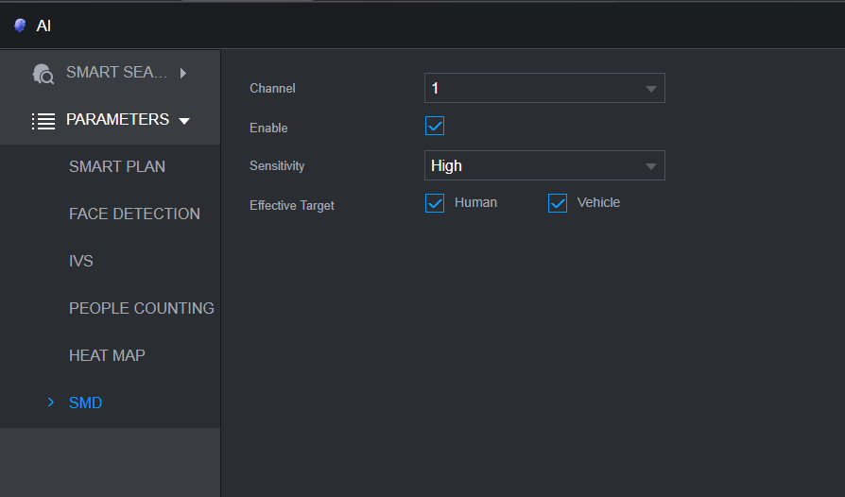
- SMD alarm configuration
- SMD reuses alarm configuration of MD.
- When SMD is enabled, MD will be enabled synchronously and its alarm configuration will be applied to SMD.
- When MD is disabled, SMD will be disabled synchronously.
- When SMD is disabled, MD continues working.
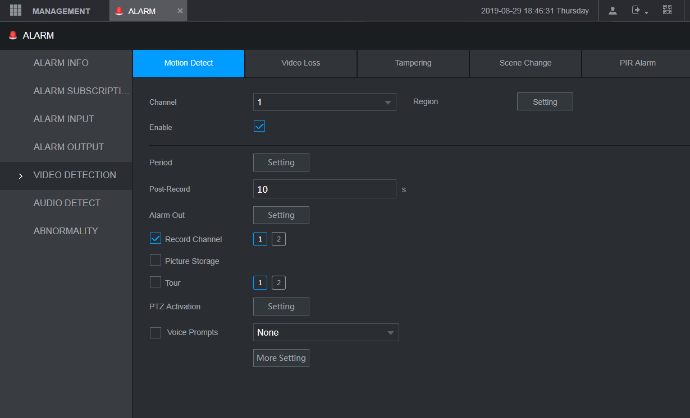
- SMD rectangle displayed on human and vehicle
You can enable SMD Preview on Display interface to display SDM rectangle on human and vehicle.
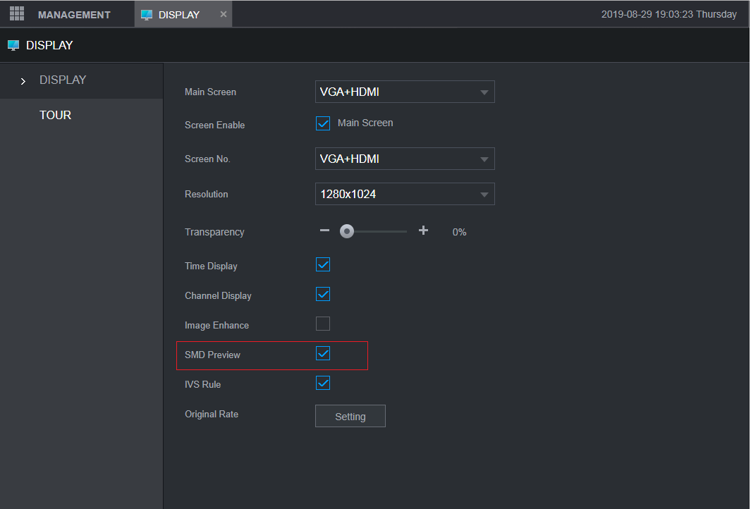
SMD rectangles are displayed as follows, flashing in every 2 seconds.
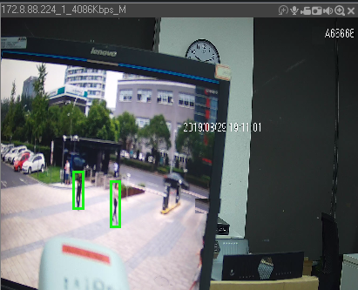
- Filtered query and playback for human and vehicle
- Query files are displayed in the color of blue.
- Enable switch reuses the switch of smart rules.
- Video playback by filtered result.
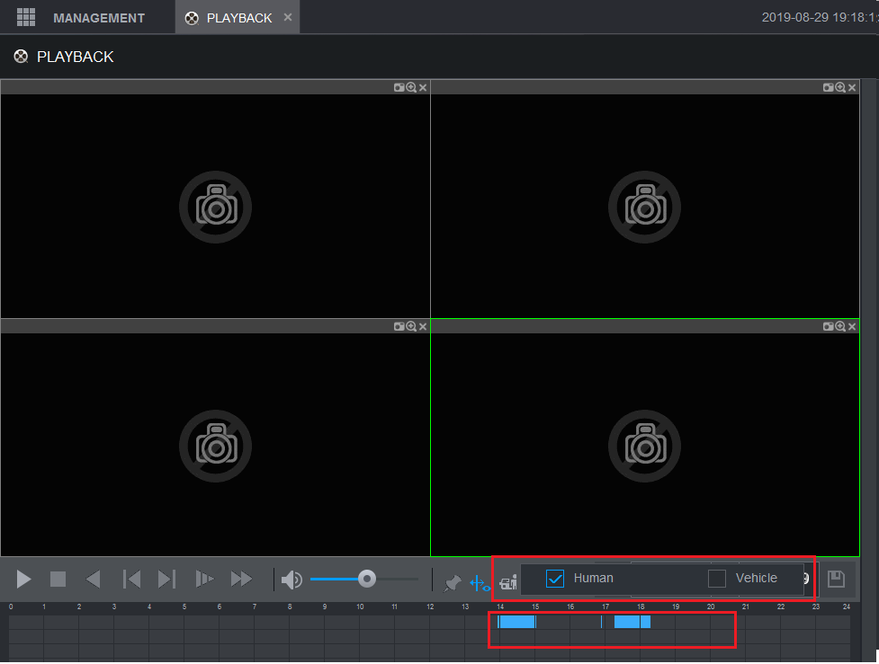
- SMD search on AI interface
You can search for SDM event on the AI interface by time, channel, human and vehicle.
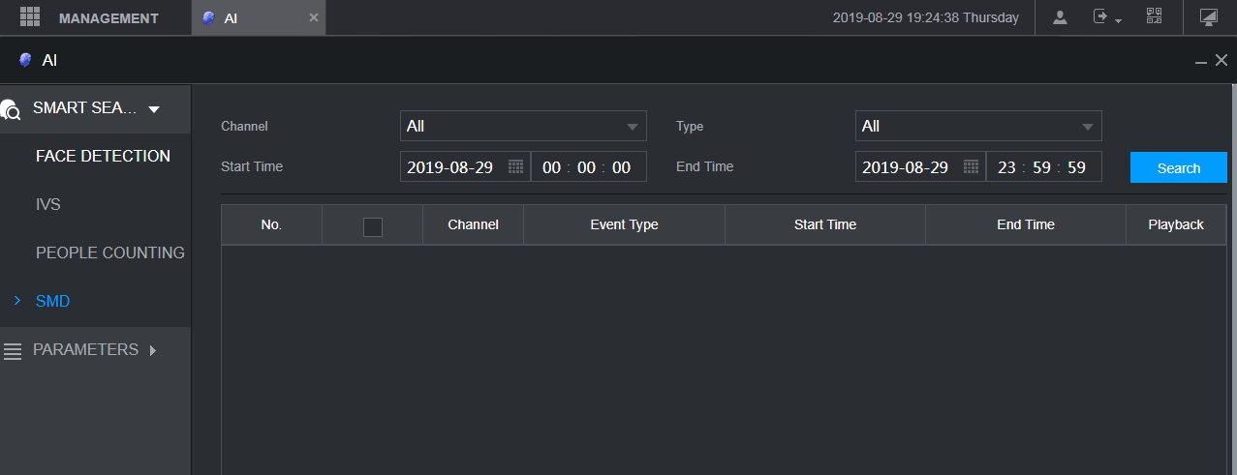
- SMD playback on AI interface
You can directly play videos in Playback column from start time to end time by filtered results.
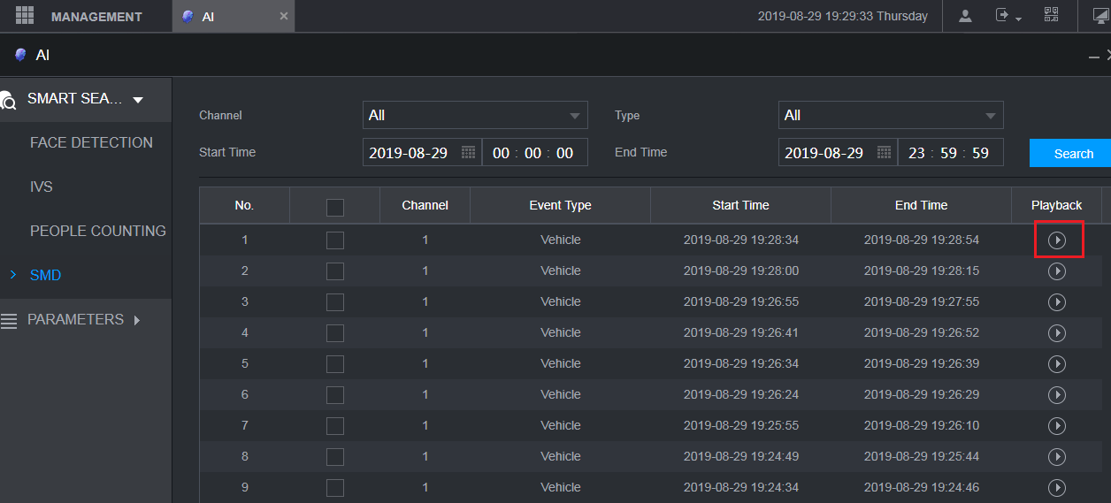
Cilck , and then a player will be prompted to play video.
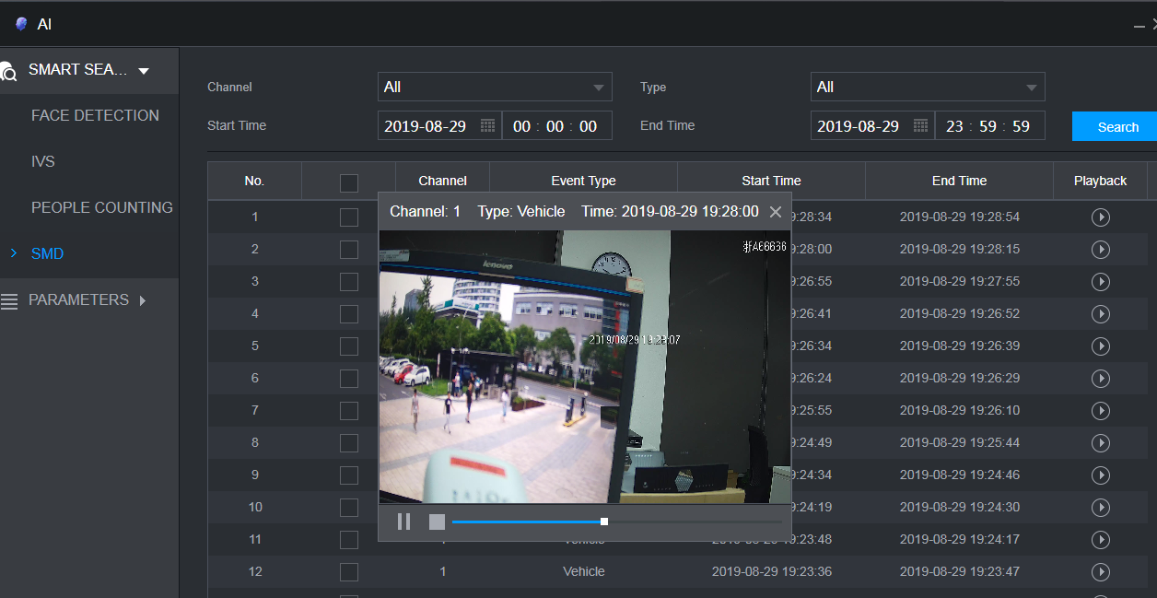

Web Browse
You can visit the web of a remote device to finish configuration through the WEB Browse function of NVR, instead of visiting the remote device separately.
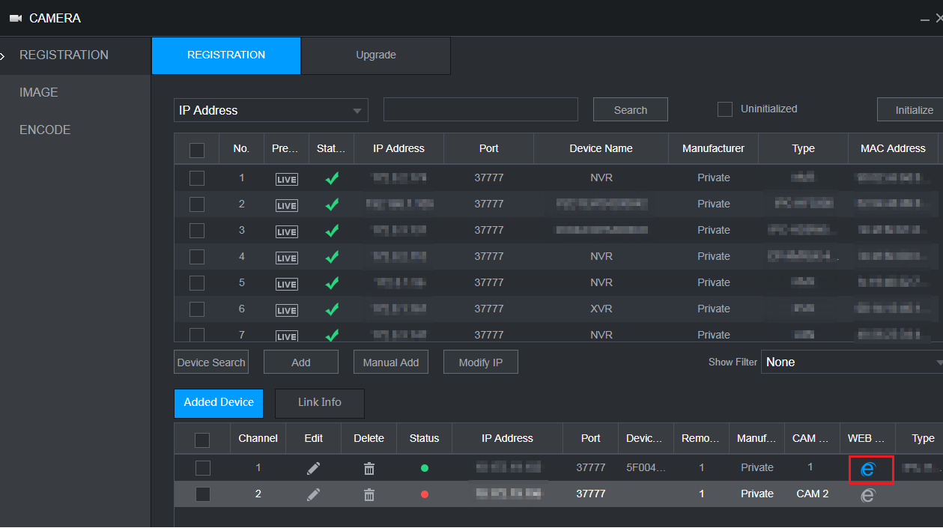
Click , and then you can visit the web of a remote device to complete normal operations.
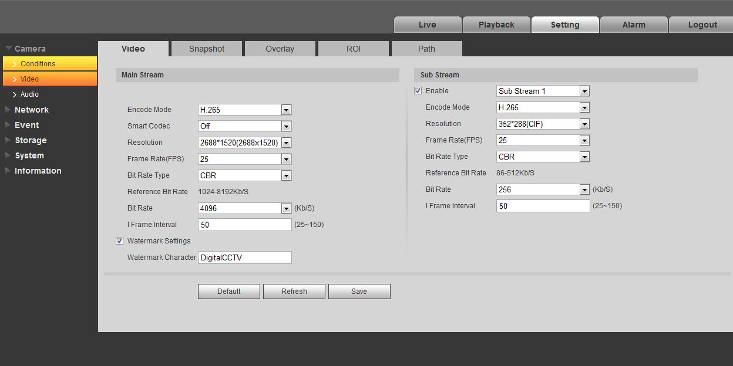

Compatibility
After updating to latest new baseline version 4.0, user cannot update back to versions lower than version 4.0

Software Environment
Model | Version
DH-IPC-HFW81230E-Z-IRA, | 2.6.01.05.06362  DH_IPC-HX8XXX-Nova_Chn_PN_Stream3_V2.640.0000004.0.R.190118.zip
DH-IPC-HF8331FP-S2, | 2.6.01.05.06365  DH_IPC-HX8XXX-Nova_MultiLang_PN_Stream3_V2.640.0000004.0.R.190118.zip
DH-IPC-HF81239F, | 2.6.01.05.06889  DH_IPC-HX8XXX-Wei-Nova2_Chn_PN_Stream3_V2.622.0000000.6.R.190130.zip
DH-IPC-HFW5233F-ZSA-27135, | 2.6.01.05.05914  DH_IPC-HX4XXX-Eos_Chn_PN_Stream3_V2.680.0000000.41.R.181212.zip
DH-IPC-HFW8239K-Z-I4-3512, | 2.6.01.05.05912  DH_IPC-HX8XXX-Eos_Chn_PN_Stream3_V2.680.0000000.41.R.181212.zip
DH-IPC-HFW8438K-Z-I4-27135, | 2.6.01.05.03379  DH_IPC-HX5X3X-Rhea_Chn_PN_Stream3_V2.622.0000000.30.R.180905.zip
DH-IPC-HFW4443M-AS-PV-I2-0360B, | 2.6.01.05.08342  DH_IPC-HX5XXX-Volt_Chn_PN_Stream3_V2.680.0000000.5.R.190404.zip
DH-IPC-HFW4833F-ZAS-3512, | 2.6.01.05.08213  DH_IPC-HX5(4)XXX-Sag_Chn_PN_Stream3_V2.800.0000000.2.R.190404.zip
DH-IPC-HFW4433K-AS-I4-0360B, | 2.6.01.05.05914  DH_IPC-HX4XXX-Eos_Chn_PN_Stream3_V2.680.0000000.41.R.181212.zip
DH-IPC-HDBW5233E-Z-X1-27135-DC12AC24V, | 2.6.01.05.07673  DH_IPC-HX5X3X-Rhea_Chn_PN_Stream3_V2.800.0000005.0.R.190325.zip
DH-IPC-HFW4631K-AS-I4-0360B, | 2.6.01.05.07673  DH_IPC-HX5X3X-Rhea_Chn_PN_Stream3_V2.800.0000005.0.R.190325.zip
DH-IPC-HFW5433E-Z-IRA-X1-0560-DC12AC24V, | 2.6.01.05.07673  DH_IPC-HX5X3X-Rhea_Chn_PN_Stream3_V2.800.0000005.0.R.190325.zip
DH-IPC-HFW5631E-Z-0735-AC24V, | 2.6.01.05.07673  DH_IPC-HX5X3X-Rhea_Chn_PN_Stream3_V2.800.0000005.0.R.190325.zip
DH-IPC-HDBW5431EP-ZE-27135, | 2.6.01.05.07655  DH_IPC-HX5X3X-Rhea_MultiLang_PN_Stream3_V2.800.0000005.0.R.190325.zip
DH-IPC-HDBW5831EP-ZE-0735, | 2.6.01.05.07655  DH_IPC-HX5X3X-Rhea_MultiLang_PN_Stream3_V2.800.0000005.0.R.190325.zip
DH-IPC-HUM8231P-E2, | 2.6.01.05.02685  DH_IPC-HX5X3X-Multi-Rhea_Eng_P_V2.622.0000000.31.R.180813.zip
DH-IPC-HUM7233-E1, | 2.6.01.05.07673  DH_IPC-HX5X3X-Rhea_Chn_PN_Stream3_V2.800.0000005.0.R.190325.zip
DH-IPC-HFW8249E-ZFR-IRA-LED-0832, | 2.6.01.05.07146  DH_IPC-HX8X4X-Warpway_Chn_PN_Stream3_V2.680.0000000.1.R.190223.zip
DH-IPC-HF8841F-FD, | 2.6.01.05.07146  DH_IPC-HX8X4X-Warpway_Chn_PN_Stream3_V2.680.0000000.1.R.190223.zip
DH-IPC-HFW8841E-ZFR-IRA-LED-67134, | 2.6.01.05.07146  DH_IPC-HX8X4X-Warpway_Chn_PN_Stream3_V2.680.0000000.1.R.190223.zip
DH-IPC-HFW8249E-ZFDI-IRA-LED-0832, | 2.6.01.05.07160  DH_IPC-HX8X4X-Warpway2_Chn_PN_Stream3_V2.680.0000000.1.R.190223.zip
DH-IPC-HDW7341X-E2-0280B, | 2.6.01.05.05281  DH_IPC-HX8X4X-Kronos_Chn_PN_Stream3_V2.622.0000000.5.R.181215.zip
DH-IPC-HFW7243K-ZPC-I4-0735, | DH_IPC-HX8X4X-Warpway2_Chn_PN_Stream3_V2.622.0000000.9.R.181119.zip
DH-IPC-HD4140X-E2-0210B, | 2.6.01.05.08217  DH_IPC-HX7XXX-Sag_Chn_PN_Stream3_V2.800.0000000.2.R.190404.zip
DH-IPC-HDW8341XP-3D-0280B, | 2.6.01.05.05284  DH_IPC-HX8X4X-Kronos_Eng_P_Stream3_V2.622.0000000.5.R.181215.zip
DH-IPC-HDW7341X-B-E2-0280B, | 2.6.01.05.02992  DH_IPC-HX8X4X-Kronos_Chn_PN_Stream3_V2.622.0000000.4.R.180816.zip
DH-IPC-HFW8449K-ZRL-LED-3512, | DH_IPC-HX8XXX-Volt_Chn_PN_Stream3_V2.680.0000000.5.R.190404.zip
DH-IPC-HFW5541EP-ZE-27135, | DH_IPC-HX5XXX-Volt_MultiLang_PN_Stream3_V2.680.0000000.5.R.190404.zip
DH-IPC-HFW5241EP-ZE-27135, | DH_IPC-HX5XXX-Volt_MultiLang_PN_Stream3_V2.680.0000000.5.R.190404.zip
DH-IPC-HFW5541EP-ZE-27135, | DH_IPC-HX5XXX-Volt_MultiLang_PN_Stream3_V2.680.0000000.5.R.190404.zip
DH-IPC-HF8242FP-FR, | 2.6.01.05.07153  DH_IPC-HX8X4X-Warpway_EngSpnFrn_PN_Stream3_V2.680.0000000.1.R.190223.zip
DH-IPC-HF8242FP-FD, | 2.6.01.05.07153  DH_IPC-HX8X4X-Warpway_EngSpnFrn_PN_Stream3_V2.680.0000000.1.R.190223.zip
DH-IPC-HF8241FP, | 2.6.01.05.07170  DH_IPC-HX8X4X-Warpway2_EngSpnFrn_PN_Stream3_V2.680.0000000.1.R.190223.zip
DH-IPC-PDBW5831P-B360-E4-2712, | 2.6.01.05.06704  DH_IPC-HX8(5)XXX-Sag_EngSpnFrn_PN_V2.622.0000000.21.R.190125.zip
DH-IPC-PDB4830P-B360-E4-0360B, | 2.6.01.05.07064  DH_IPC-HX8(5)XXX-Sag_EngSpnFrn_PN_V2.622.0000000.22.R.190225.zip
DH-PSDW5631SP-B360-E4-D204-DC12V, | 2.6.01.05.06035  DH_IPC-HX8(5)XXX-Sag_EngSpnFrn_PN_V2.622.0000000.20.R.190110.zip
DH-IPC-PFW8809-H-A180-E4-AC24V, | DH_IPC-PFW8XXX-Nova_Chn_PN_Stream3_V2.622.0000000.3.R.181201.zip
DH-PSDW81649-H-A360-E9, | DH_IPC-PSD8XXX-Fafnir_Chn_PN_Stream3_V2.622.0000000.1.R.181205.zip
DH-PSD81602P-H-A360-E9, | DH_IPC-PSD8XXX-Nova_Eng_P_Stream3_V2.460.0000.4.R.20170927.zip
DH-IPC-PFW8802P-H-A180-E4-AC24V, | DH_IPC-PFW8XXX-Nova_Eng_P_Stream3_V2.622.0000000.3.R.181201.zip
DH-IPC-HDBW4231FP-E2-M-0360B, | 2.6.01.05.02685  DH_IPC-HX5X3X-Multi-Rhea_Eng_P_V2.622.0000000.31.R.180813.zip
DH-IPC-EW5431-ASW, | 2.1.02.01.17602  DH_IPC-HX5X3X-Rhea_Chn_PN_Stream3_V2.460.0000000.16.R.20170919.zip
DH-IPC-EB5531, | 2.6.01.05.07655  DH_IPC-HX5X3X-Rhea_MultiLang_PN_Stream3_V2.800.0000005.0.R.190325.zip
DH-IPC-EBW81230, | 2.6.01.05.06903  DH_IPC-HX8XXX-Nova2_Chn_PN_Stream3_V2.622.0000000.6.R.190130.zip
DH-IPC-EBW8630P, | 2.6.01.05.06908  DH_IPC-HX8XXX-Nova2_EngSpnFrn_PN_Stream3_V2.622.0000000.6.R.190130.zip
DH-IPC-EBW81230P, | 2.6.01.05.06908  DH_IPC-HX8XXX-Nova2_EngSpnFrn_PN_Stream3_V2.622.0000000.6.R.190130.zip
ITC237-PU1B-IR, | 2.6.01.08.01701  General_ITC237-PU1B(PW1B)-IR(IRZ)(L)_Eng_PN_Oversea_Europe_V2.622.0000000.1.R.181114.zip
ITC237-PW1B-IRZ, | 2.6.01.08.01701  General_ITC237-PU1B(PW1B)-IR(IRZ)(L)_Eng_PN_Oversea_Europe_V2.622.0000000.1.R.181114.zip
ITC215-PW4I, | General_ITC215-PW4I-XXX_Eng_PN_Oversea_ITCPUSH_EuropeENTRANCE_V2.623.0000000.0.R.180930.zip
ITC952-RF2D, | General_ITCXX2-RF2D-IR_Eng_PN_Oversea_3G_V2.622.0000000.7.R.190321.zip
ITC352-RF2D, | General_ITCXX2-RF2D-IR_Eng_PN_Oversea_3G_V2.622.0000000.7.R.190321.zip
ITC302-RF2D, | General_ITCXX2-RF1D(RF2D)_Chn_P_V2.722.0000000.0.R.190409.zip
ITC902-RF2D, | General_ITCXX2-RF1D(RF2D)_Chn_P_V2.722.0000000.0.R.190409.zip
ITC235-RF1D, | General_ITC235-RF1D_Chn_P_V2.622.0000000.0.R.180424.zip
ITC235-RF2E, | General_ITC235-RF1E(RF2E)_Chn_P_Stream3_V2.620.0000000.0.R.180705.zip
ITC835-RF1D, | General_ITC835-RF1D_Chn_PN_V2.622.0000000.0.R.180818.zip
ITC302-SF2D-QD, | General_ITC302-SF2D-QD_Chn_P_V2.622.0000000.0.R.180611.zip
ITC902-SF2D-QA, | General_ITC902-SF2D-QA_Chn_P_V2.622.0000000.0.R.180425.zip
ITC902-SF2D-QB, | General_ITC902-SF2D-QB_Chn_P_V2.401.0000000.1.R.180509.zip
ITC215-PW5H-F3, | General_ITC215-PW5H-F(R)_Chn_PN_GAYSITCPUSH_Mainland_V2.622.0000000.2.R.180929.zip
ITC215-PW5H, | General_ITC215-PW5H-F(R)_Chn_PN_GAYSITCPUSH_Mainland_V2.622.0000000.2.R.180929.zip
ITC314-PH2A, | General_ITCXX4-PH1B(PH1C)(PH2A)-(TF2)_Chn_PN_GAYS_Mainland_V2.622.0000000.1.R.180418.zip
DH-TPC-BF8x21 | General_TPC-BF8X21_V2.200.0000000.5.R.190327.zip
DH-SD-8A1840WA-HNF, | 2.6.01.05.07347  DH_SD-Fafnir_Chn_PN_Stream3_V2.623.0000000.13.R.190227.zip
SD6CE230U-HNI, | 2.6.01.05.06726  DH_SD-Eos_MultiLang_PN_Stream3_V2.623.0000000.17.R.190119.zip
DH-SD-1A1203UE-GN-PD, | 2.1.01.04.10167  DH_SD-Eos-Civil_Chn_PN_Stream3_V2.622.0000000.13.R.180328.zip
DH-SD29204UE-GN-W, | 2.6.01.05.06270  DH_SD-Eos-Civil_MultiLang_PN_Stream3_V2.623.0000000.17.R.190119.zip
DH-SD6C82F-HNP(ZJ)-A | 2.6.01.05.08251  DH_SD-Eos_Chn_PN_Stream3-ZhouJie_V2.623.0000000.17.R.190119.zip
DH-SD-6C3440XA-HNR, | 2.6.01.05.06793  DH_SD-Prometheus_Chn_PN_Stream3_V2.623.0000000.5.R.190220.zip
DH-SDT-5A404WA-C4F, | 2.6.01.05.07333  DH_SD-Fafnir_Chn_PN_Stream3-Lingtong_V2.623.0000000.13.R.190227.zip
DH-SDT-8A1840WA-T8Z4, | 2.6.01.05.08301  DH_SD-Fafnir_Chn_PN_Stream3-Tianshu_V2.800.0000000.1.R.190402.zip
DH-VTO9341D-S, | 2.6.01.18.01051  General_VTO9341D-S_Chn_P_SIP_V1.000.0000000.5.R.20181010.zip
DH-VTT201, | 2.6.01.18.00886  General_VTT201_Chn_P_16M_SIP_V1.001.0000000.2.R.20180817.zip
DHI-DSS7016D-S2, | General_OverseasDSS7016S2_Eng_Basic_V1.000.0000000.0.R.20181130.tar.gz,
DSS7016D-S2-I, | During development.
DSSC9100/C9505 | During development.
IBSP-PRO | 2.7.01.07.00243  General_iBSP_Chn_Oracle_IS_V4.000.0000001.0.R.20190122.tar.gz
H8900, | 2.7.01.08.00410  General_DSS-H8900_Chn_Basic_V3.001.0000001.7.R.20190131.tar.gz
NKB1000, | General_NETKB1000_Chn_V2.610.0000.4.R.20161024.zip,
NKB5000, | DH_NKB5000_Chn_V3.210.0003.0.R.170930.BIN,
NVD0405DH-4K, | General_NVD0405DH-4K_Chn_P_V3.200.0002.00.R.20170713.zip
NVD0905DH-4I-4K, | General_NVD0905DH-4K_Chn_V3.200.0003.0.R.170509.BIN
SmartPSS | DH_SmartPSS_ChnEng_Win32_IS_V2.02.0.R.171124.zip,
DMSS | 2.1.02.01.10709  General_DMSS-IOS-Phone-Lite-Device_Internel_Basic_IS_V3.24.000.R.140928.ipa
Player | General_Player_Chn_WIN32_V3.44.0.R.170421.zip,
ConfigTool | General_ConfigTool_ChnEng_V4.011.0000001.4.R.20190305.zip,
NetSDK | General_NetSDK_Chn_Win64_IS_V3.050.0000005.3.R.190225.7z,
DiskManager

Pending Issues
None.

Update Guide
None.
ZHEJIANG DAHUA VISION TECHNOLOGY CO., LTD.
Address: No.1199, Bin'an Road, Binjiang District, Hangzhou, P.R. China
Postcode: 310053
Tel: +86-571-87688883
Fax: +86-571-87688815
Email: overseas@dahuatech.com
Website: www.dahuasecurity.com

