1 下载程序包，以0612程序为例
General_VTH53X1_MultiLang_SIP_V4.400.9992000.4.R.20200612.zip
2 解压程序得到两个update文件，将update.zip重命名为update.bin ，用于升级。
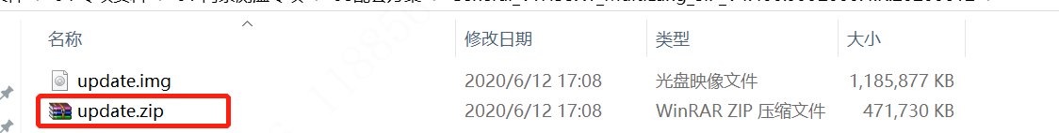
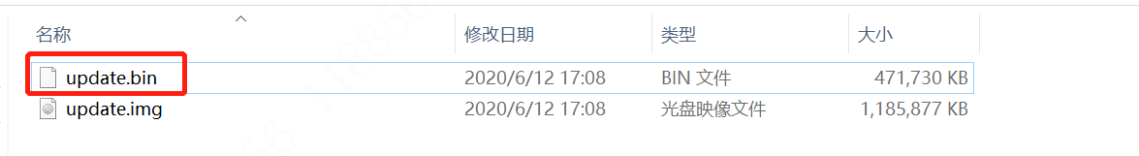

1 Download the program package, taking the 0612 program as an example
General_VTH53X1_MultiLang_SIP_V4.400.9992000.4.R.20200612.zip
2 Unzip the program to get two update files, rename "update.zip" to "update.bin" and use "update.bin" as the upgrade file.

